***Dt : 2/5/2022***

***\*imp***

***DataTypes,Variables and Methods:***

***DataTypes in Java:***

***=>Types of data which we are expecting as input to JavaProgram***

***are known as 'DataTypes in Java'***

***=>DataTypes in Java are categorized into two types:***

***1.Primitive DataTypes***

***2.Non-Primitive DataTypes***

***1.Primitive DataTypes:***

***=>The single valued data formats are known as Primitive***

***DataTypes or Fundamental DataTypes or Basic DataTypes.***

***=>These Primitive DataTypes are categorized into four types:***

***(a)Integer datatypes***

***(b)Float datatypes***

***(c)Character datatype***

***(d)boolean datatype***

***(a)Integer datatypes:***

***=>The Numeric data without decimal point are known as Integer***

***datatypes.***

***=>Types:***

***(i)byte - 1 byte(8-bits)***

***(ii)short - 2 bytes***

***(iii)int - 4 bytes***

***(iv)long - 8 bytes***

***Note:***

***=>byte and short datatypes are used for Stream data.***

***(MultiMedia data)***

***=>int datatype is used in normal programming process.***

***=>long datatype is to hold big integer values like PhoneNo,***

***AccNo,CardNo,...***

***=>In Java,when we want to assign long value we must use "L" or***

***"l" in the RHS of declaration.***

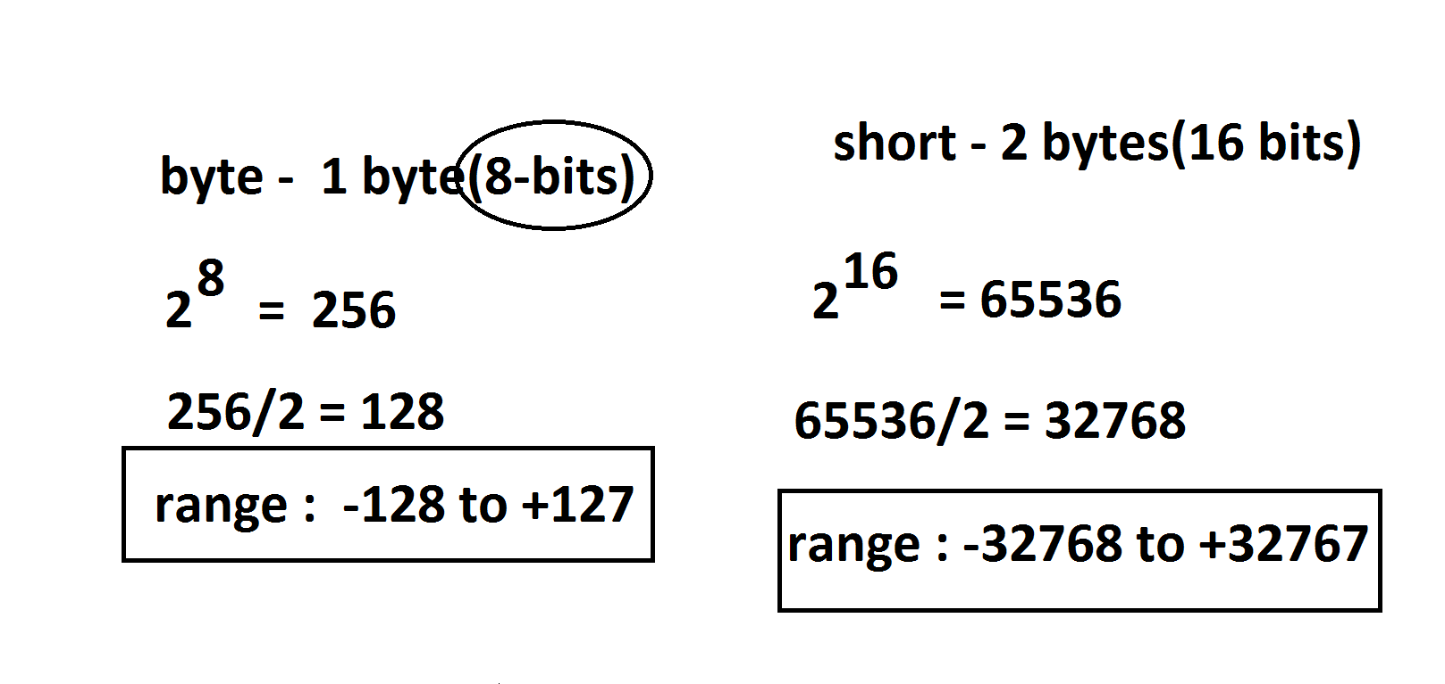

***(b)Float datatypes:***

***=>The numeric data with decimal point are known as Float***

***datatypes.***

***=>Types:***

***(i)float - 4 bytes***

***(ii)double - 8 bytes***

***Note:***

***=>float datatype is used in normal programming process.***

***=>double datatype is used to hold biggest float values.***

***=>In Java,when we want to assign float value we must use "F"***

***or "f" in the RHS of declaration.***

***Summary:***

***=>According to compilation process,***

***=>The numeric value without decimal point automatically***

***considered as 'int' datatype.***

***=>The numeric value with decimal point automatically***

***considered as 'double' value.***

***(c)Character datatype:***

***=>The single valued character which is represented in single***

***quotes is known as Character datatype.***

***Ex:***

***'k','n',...***

***=>Types:***

***char - 2 bytes***

***(d)boolean datatype:***

***=>The datatype which is available in the form of true or false***

***is known as boolean datatype.***

***=>Types:***

***boolean - 1 bit***

***Ex_Program : DataTypes.java***

***class DataTypes***

***{***

***public static void main(String[] args)***

***{***

***byte b = 127;***

***short s = 32767;***

***int i = 641234;***

***long l = 9898981234L;***

***float f = 12.34F;***

***double d = 2345.67;***

***char ch = 'A';***

***boolean bl = true;***

***System.out.println("byte value = "+b);***

***System.out.println("short value = "+s);***

***System.out.println("int value = "+i);***

***System.out.println("long value = "+l);***

***System.out.println("float value = "+f);***

***System.out.println("double value = "+d);***

***System.out.println("char value = "+ch);***

***System.out.println("boolean value = "+bl);***

***}***

***}***

***o/p:***

***byte value = 127***

***short value = 32767***

***int value = 641234***

***long value = 9898981234***

***float value = 12.34***

***double value = 2345.67***

***char value = A***

***boolean value = true***

***=======================================================***

***faq:***

***define TypeCasting?***

***=>The process of converting one data type value into another***

***datatype value is known as Type Casting process.***

***=>TypeCasting process can be done in two ways:***

***(a)Widening process***

***(b)Narrowing process***

***(a)Widening process:***

***=>The process of converting Lower datatypes into Higher data***

***types is known as Widening process.***

***char->byte->short->int->long->float->double***

***=>This Widening process is also known as UpCasting process or***

***Implicit TypeCasting process***

***(b)Narrowing process:***

***=>The process of converting Higher datatypes into Lower data***

***types is known as Narrowing process.***

***double->float->long->int->short->byte->char***

***=>This Narrowing process is also known as DownCasting process or***

***Explicit TypeCasting process.***

***==========================================================***

***Assignment-2:(Solution)***

***wap to calculte the percentage of Student?***

***Program : StudentResult.java***

***class StudentResult***

***{***

***public static void main(String[] args)***

***{***

***int s1=77,s2=67,s3=57,s4=73,s5=87,s6=72;***

***int totMarks = s1+s2+s3+s4+s5+s6;***

***float per=(float)totMarks/6;***

***System.out.println("s1="+s1);***

***System.out.println("s2="+s2);***

***System.out.println("s3="+s3);***

***System.out.println("s4="+s4);***

***System.out.println("s5="+s5);***

***System.out.println("s6="+s6);***

***System.out.println("TotMarks="+totMarks);***

***System.out.println("Percentage="+per);***

***}***

***}***

***o/p:***

***s1=77***

***s2=67***

***s3=57***

***s4=73***

***s5=87***

***s6=72***

***TotMarks=433***

***Percentage=72.166664***

***===================================================***

***Assignment:***

***wap to calculate and display totSal of an emmployee based on***

***bSal?***

***bSal = 12000***

***totSal = bSal+HRA+DA;***

***HRA = 93% of bSal***

***DA = 63% of bSal***

***==========================================================***